Notes:
- AS400 Relay Card is to convert UPS signals into real potential-free Dry Contacts for industrial controls.
- AS400 Relay Card can only be used on Powercom Vanguard UPS Series (which is equipped with a Smart Slot (i.e., SNMP Slot).
- The following are the pictures of the AS400 Relay Card:

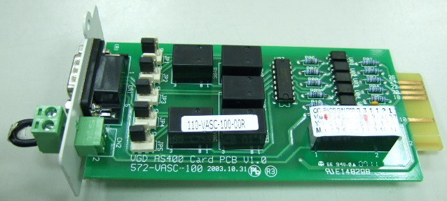
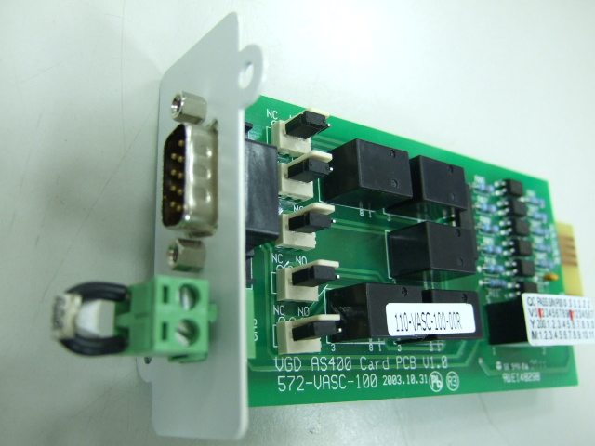

EPO (Emergency Power Off) Contacts Pin-Out (DB9 Male Connector)

- Dry Contact Signals and Pin-Out Details at DB9 Male Connector:
PIN # | Description | I/O type
1 | UPS fail, relay contact, normally open active close. | output
2 | Summary alarm, relay contact, normally open, active close.  One of the following conditions activate this signal  Output fault.  Bus fault.  Over temperature.  Overload.  Over Charging.  Battery test fail.  Charger failure. | output
3 | GND for secondary
4 | Remote shutdown  a. Battery Mode: Apply "signal" 5V~12Vdc for >0.5 sec. then UPS will shutdown completely.  b. Line Mode: Provide "signal" 5V~12Vdc for > 0.5 sec. then UPS will interrupt the output Power. | input
5 | Common
6 | Bypass active, normally open, active close | output
7 | Battery low, normally open, active close | output
8 | Not Connected
9 | Utility fail, normally open, active close | output

- The Rating of Relay Contacts:
All the Relay Dry Contacts of the AS400 Relay Card are rating 1A 24Vdc or 1A 120Vac.
- On the economic version of Vanguard UPS, there will be no EPO provision on the Rear Panel. AS400 Relay Card can also be used on the economic version of Vanguard UPS, so that the economic version of Vanguard UPS will also be able to provide EPO function.
When the AS400 Relay Card is used on the Regular version of Vanguard UPS, both of the EPO on the Rear Panel and one the AS400 Relay Card are functional. Disconnecting any one of these EPO will turn off the UPS.

Remark:
For details, Please see the Schematic Diagram in the next page.

